EXPT NO: 7 | GENERATE SYNTHETIC IMAGES USING A GENERATIVE ADVERSARIAL NETWORK (GAN)
DATE: 05.10.2026

PRE-LAB QUESTIONS (PROVIDE BRIEF ANSWERS TO THE FOLLOWING QUESTIONS)

- What is a Generative Adversarial Network (GAN)?

A Generative Adversarial Network (GAN) is a deep learning model used to generate new data that resembles real data. It consists of two neural networks called the Generator and Discriminator.

- What are the roles of the Generator and Discriminator in a GAN?

• Generator: Generates synthetic images from random noise.
• Discriminator: Determines whether an image is real or generated.
• Both networks compete with each other during training.

- Why are GANs used for synthetic image generation?
GANs are used because they can learn the patterns and features of real images and generate new, realistic-looking synthetic images.

- What is the difference between real images and synthetic images?

• Real images: Obtained directly from an actual dataset or source.
• Synthetic images: Artificially generated by a model such as a GAN.

- Explain the concept of adversarial training in GANs.
Adversarial training means that the Generator and Discriminator compete with each other. The Generator tries to create realistic images, while the Discriminator tries to distinguish real images from generated images. This competition improves the Generator over time.

AIM
To implement a Generative Adversarial Network (GAN) for generating synthetic images by training a Generator and Discriminator on an image dataset and evaluating the quality of the generated images.

SOFTWARE REQUIREMENTS
- Python
- TensorFlow / Keras
- Google Colab
- GitHub
- NumPy
- Matplotlib
- Pandas

OBJECTIVES
Students will be able to:
- Understand the architecture and working of Generative Adversarial Networks.
- Understand the roles of the Generator and Discriminator.
- Prepare and preprocess an image dataset for GAN training.
- Build a Generator network for synthetic image generation.
- Build a Discriminator network for distinguishing real and generated images.
- Train a GAN using adversarial learning.
- Generate synthetic images using the trained Generator.
- Visualize and analyze the quality of generated images.

PROCEDURE
PART A: DATASET PREPARATION AND IMAGE PREPROCESSING
Perform the following tasks:
- Load an image dataset such as the MNIST handwritten digit dataset.
- Explore the dataset and examine sample images.
- Check the number of images and image dimensions.
- Display sample images from the dataset.
- Normalize the pixel values to the range [-1, 1].
- Reshape the images into the required input format.
- Prepare the dataset for batch-wise training.
- Create a data pipeline using appropriate TensorFlow/Keras utilities.
(CODE: CONATAINS STUDENT ROLL NOS
SCREENSHOT OF CODE
SCREENSHOT OF OUTPUT)

PART B: IMPLEMENTING THE GENERATOR
Perform the following tasks:
- Define a random noise vector as the input to the Generator.
- Create the Generator using appropriate neural network layers.
- Use Dense and convolutional/transposed convolutional layers to generate images.
- Apply appropriate activation functions.
- Generate an image from a random noise vector.
- Display the generated image before GAN training.
- Display the Generator model architecture and summary.
(CODE: CONATAINS STUDENT ROLL NOS
SCREENSHOT OF CODE
SCREENSHOT OF OUTPUT)

PART C: IMPLEMENTING THE DISCRIMINATOR AND GAN MODEL
Perform the following tasks:
- Create a Discriminator network to classify images as real or generated.
- Add convolutional layers to extract image features.
- Add appropriate activation functions.
- Add a final output layer for binary classification.
- Compile the Discriminator using:
  - Appropriate optimizer
  - Binary cross-entropy loss
- Combine the Generator and Discriminator to form the GAN.
- Display the Generator and Discriminator model summaries.
(CODE: CONATAINS STUDENT ROLL NOS
SCREENSHOT OF CODE
SCREENSHOT OF OUTPUT)

PART D: GAN TRAINING AND SYNTHETIC IMAGE GENERATION
Perform the following tasks:
- Initialize the Generator with random noise.
- Train the Discriminator using:
  - Real images from the dataset.
  - Synthetic images generated by the Generator.
- Train the Generator through the combined GAN model.
- Record:
  - Generator loss
  - Discriminator loss
- Repeat the training process for the specified number of epochs.
- Generate synthetic images at regular training intervals.
- Visualize generated images at different stages of training.
- Compare the generated images with real images.
- Analyze the quality and diversity of the generated images.
- Save the final generated images.
(CODE: CONATAINS STUDENT ROLL NOS
SCREENSHOT OF CODE
SCREENSHOT OF OUTPUT)
CODE:
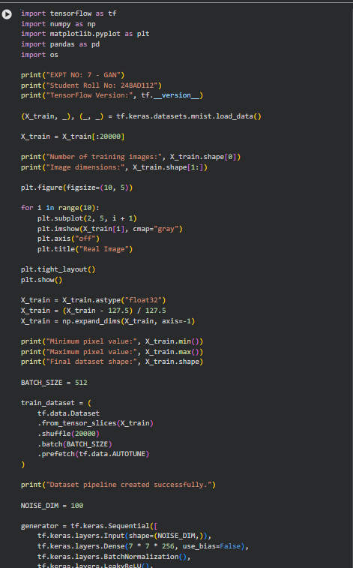

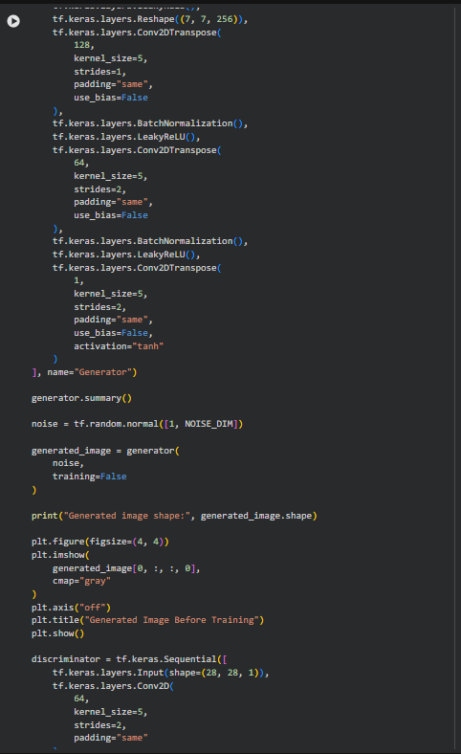

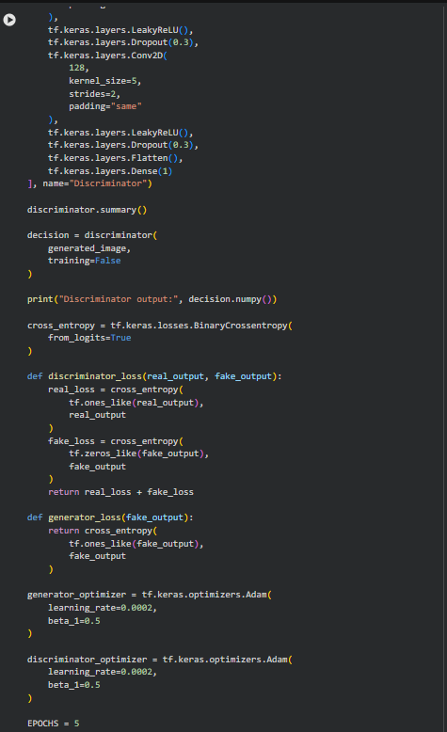

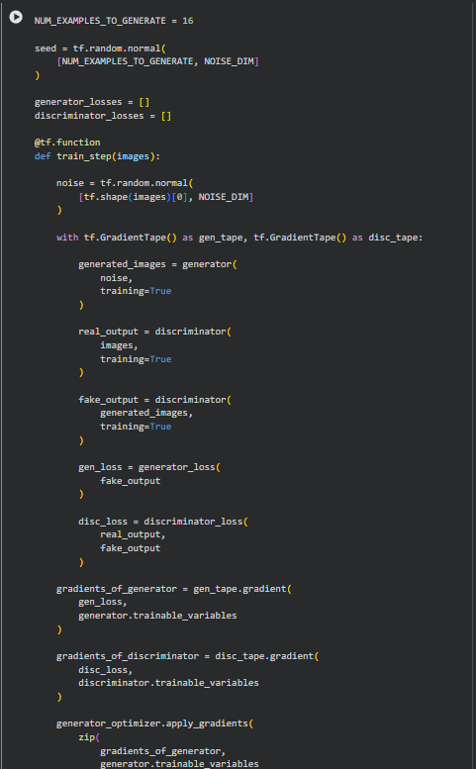

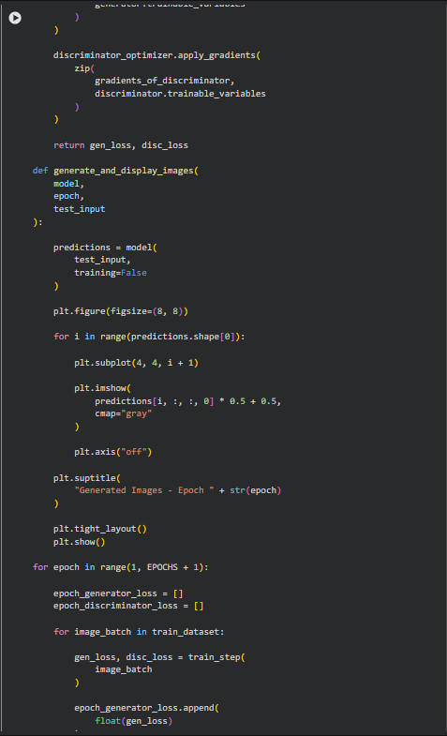
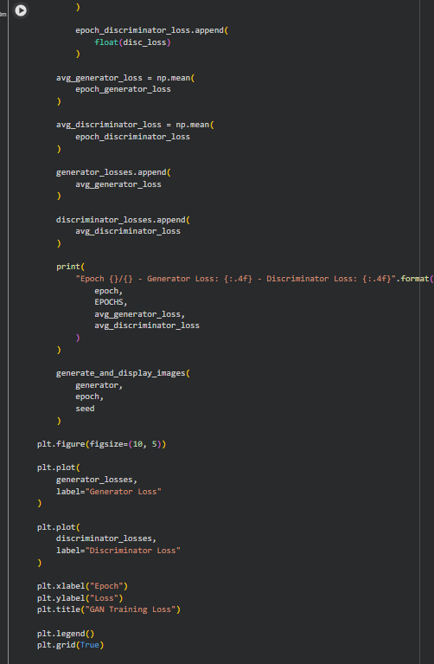

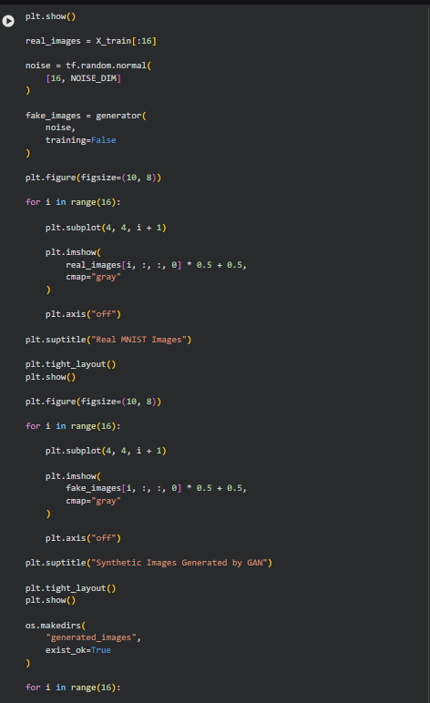

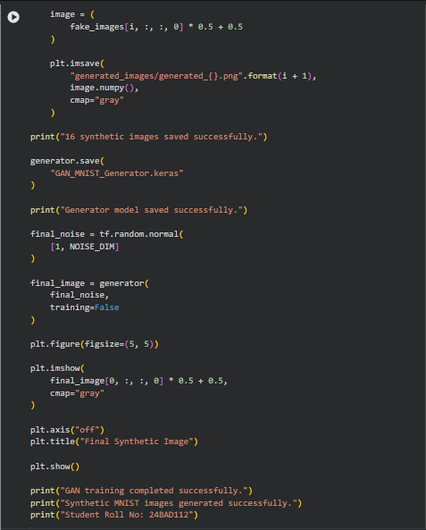
OUTPUT:
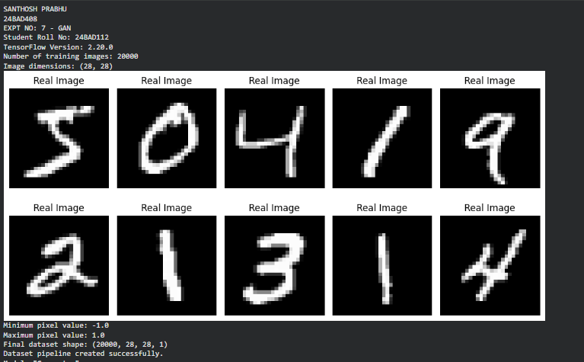

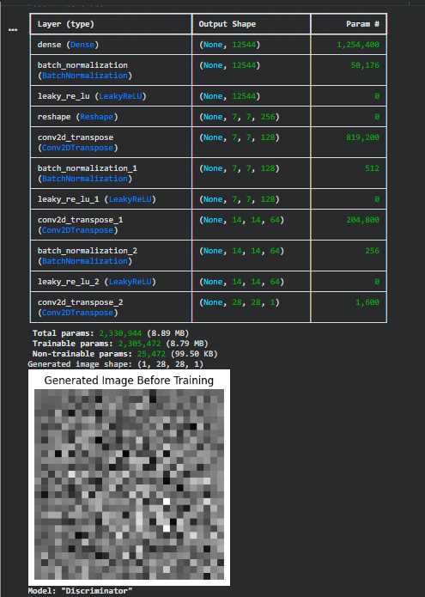
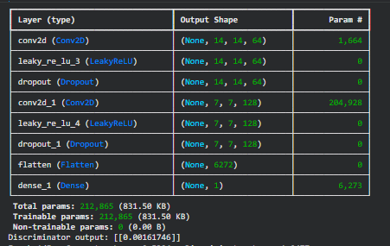

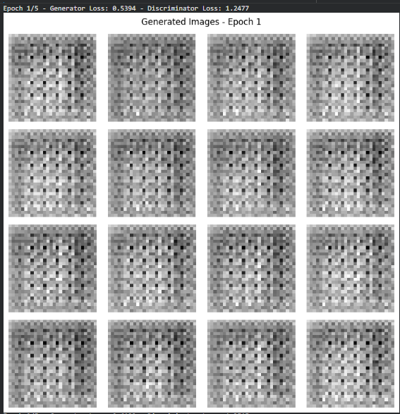

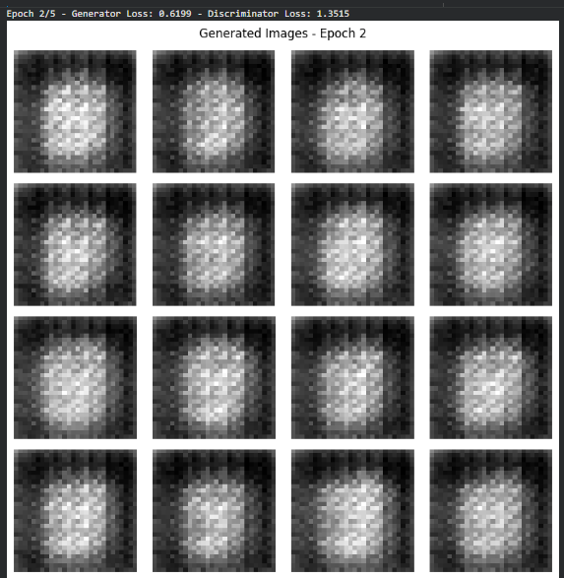

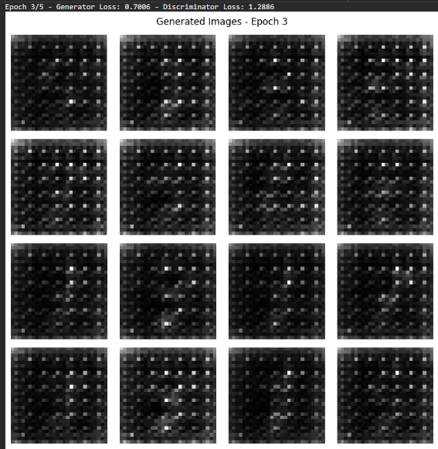

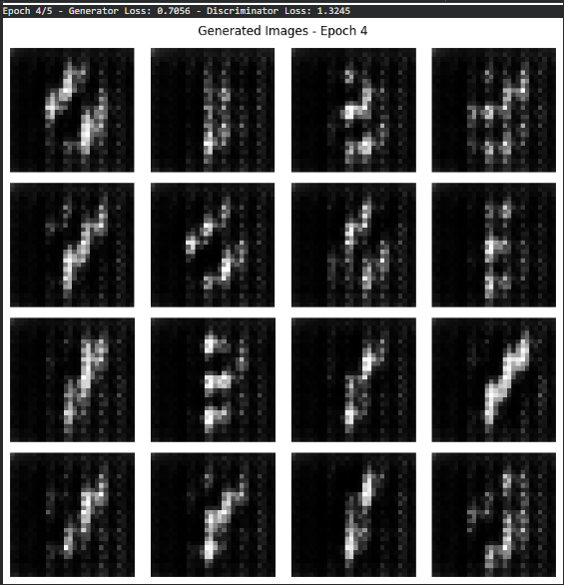

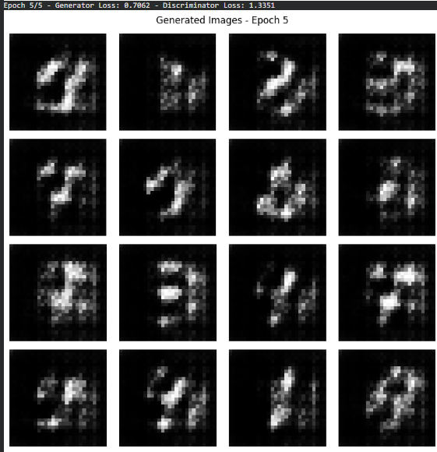

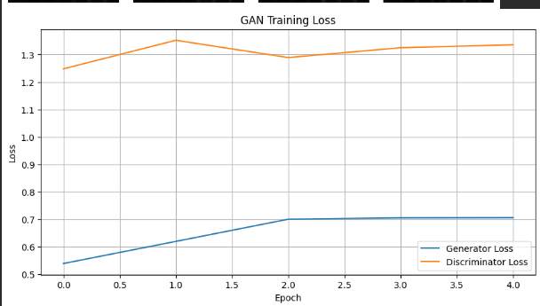

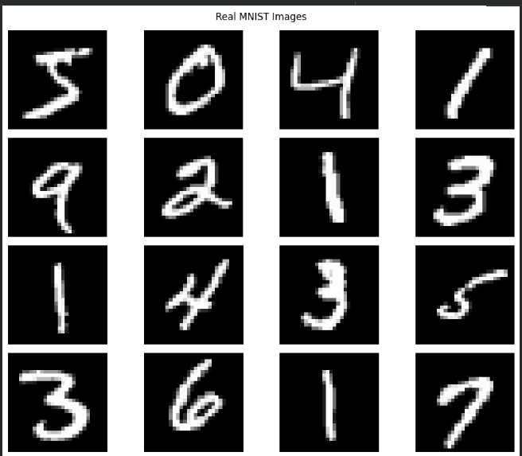

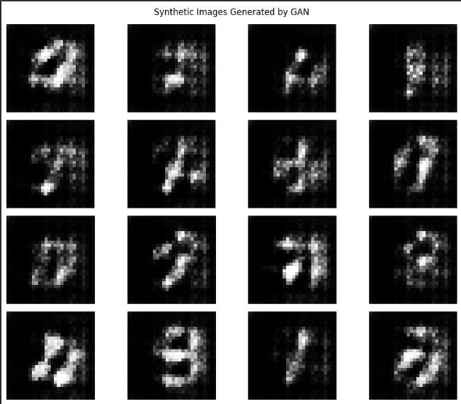

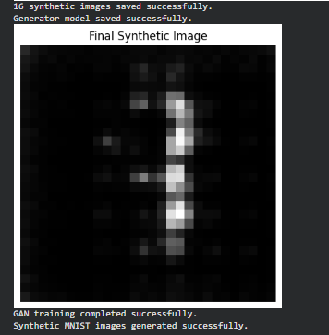

EXPECTED OUTCOME
Students will understand the architecture and working of Generative Adversarial Networks (GANs) and the interaction between the Generator and Discriminator during adversarial training. Students will learn to preprocess image data, build and train GAN models, and generate synthetic images. They will evaluate the generated images by visually comparing them with real images and analyzing the improvement in image quality during training.

POST-LAB QUESTIONS (PROVIDE BRIEF ANSWERS TO THE FOLLOWING QUESTIONS)

- What is the role of the Generator in a GAN?

The Generator creates synthetic images from random noise and tries to make them look similar to real images.

- What is the role of the Discriminator in a GAN?

The Discriminator classifies an input image as either real or generated.

- Why is random noise used as input to the Generator?

Random noise provides different starting points to the Generator, allowing it to produce different synthetic images.

- What happens when the Discriminator becomes too strong during GAN training?

If the Discriminator becomes too strong, it can easily identify generated images as fake. This gives the Generator weak learning signals and can make training difficult.

- What is meant by mode collapse in GANs?

Mode collapse occurs when the Generator produces very similar images repeatedly instead of generating diverse outputs.
- How does the Generator improve the quality of generated images during training?

The Generator receives feedback through the Discriminator and updates its weights to create images that are increasingly difficult for the Discriminator to distinguish from real images.

- Mention one real-world application of GANs.

GANs can be used for image generation and image enhancement, such as creating realistic synthetic images.

- What is the difference between GAN training and conventional neural network training?
In conventional neural networks, a model generally learns from a fixed objective using labeled or target data. In GANs, the Generator and Discriminator are trained against each other, creating an adversarial learning process.

SUGGESTIONS FOR DATASETS
- MNIST Handwritten Digits – https://www.tensorflow.org/datasets/catalog/mnist
- Fashion-MNIST – https://www.tensorflow.org/datasets/catalog/fashion_mnist
- CIFAR-10 – https://www.tensorflow.org/datasets/catalog/cifar10
- CelebA – https://www.tensorflow.org/datasets/catalog/celeb_a
- Oxford-IIIT Pet Dataset – https://www.tensorflow.org/datasets/catalog/oxford_iiit_pet

ASSESSMENT
Description | Max Marks | Marks Awarded
Pre Lab Exercise | 5
In Lab Exercise | 10
Post Lab Exercise | 5
Viva | 10
Total | 30
Faculty Signature

